Meta Title:
Lash Tech School in Houston, TX – Start Your Beauty Career Today
Meta Description:
Image Academy offers well-rounded lash tech courses in Houston, TX to provide students with expertise in lash extension tools and techniques. Join Today!
Lash Tech Page
https://imageacademy.org/lash-tech/
lash tech | 4400 | 33
lash tech classes | 1900 | 26
lash tech certification | 1600 | 29
lash tech school | 1000 | 35
lash tech near me | 12100 | 20
lash tech classes near me | 1000 | 23

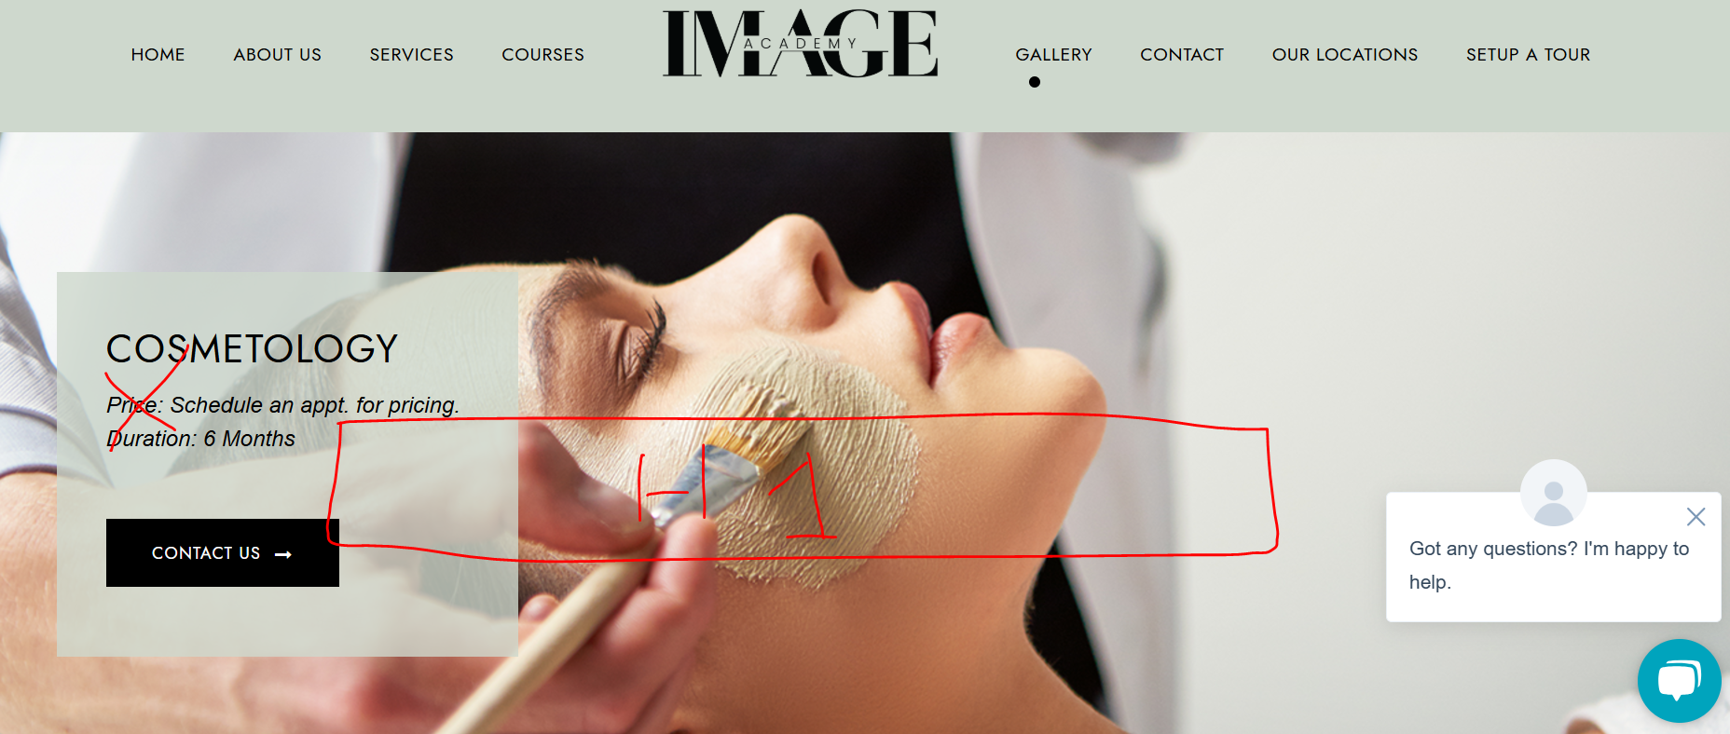

Lash Tech School in Houston, TX (h1)
Master the Art of Lash Tech Extension at Image Academy in Houston.
Become a Certified Lash Tech

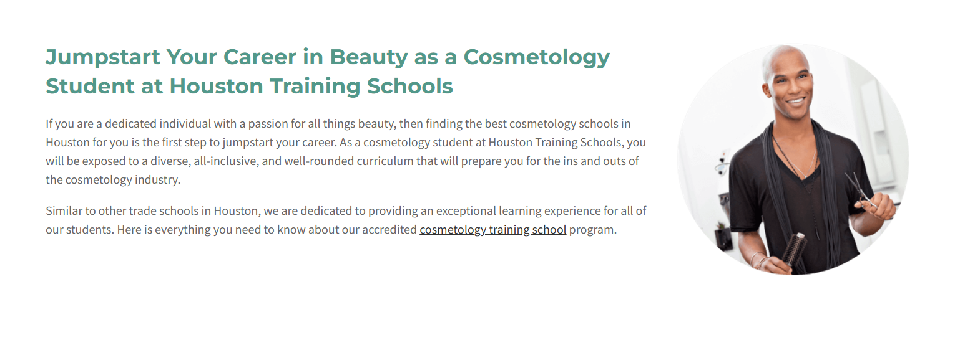

Be the Lash Master You Want to Be At Image Academy (h2)
Here at Image Academy, we realize when you have a true passion for lash extensions you wish to receive only the best training. That’s why we provide the best lash extension courses for those who want to become lash technicians. With the help of fully interactive courses, experienced tutors, and practical training, our trainers will help you unleash your potential and acquire the skills needed to succeed in the beauty industry.
Explore our lash tech classes program and our modern and optimized equipment that create steep learning curves aimed at mastery of eyelash extensions, lash lifts, and many others. Don’t wait any longer, join Image Academy today and enter into a realm of unlimited possibilities to design remarkable change for your clients.
CTA: Enroll Today

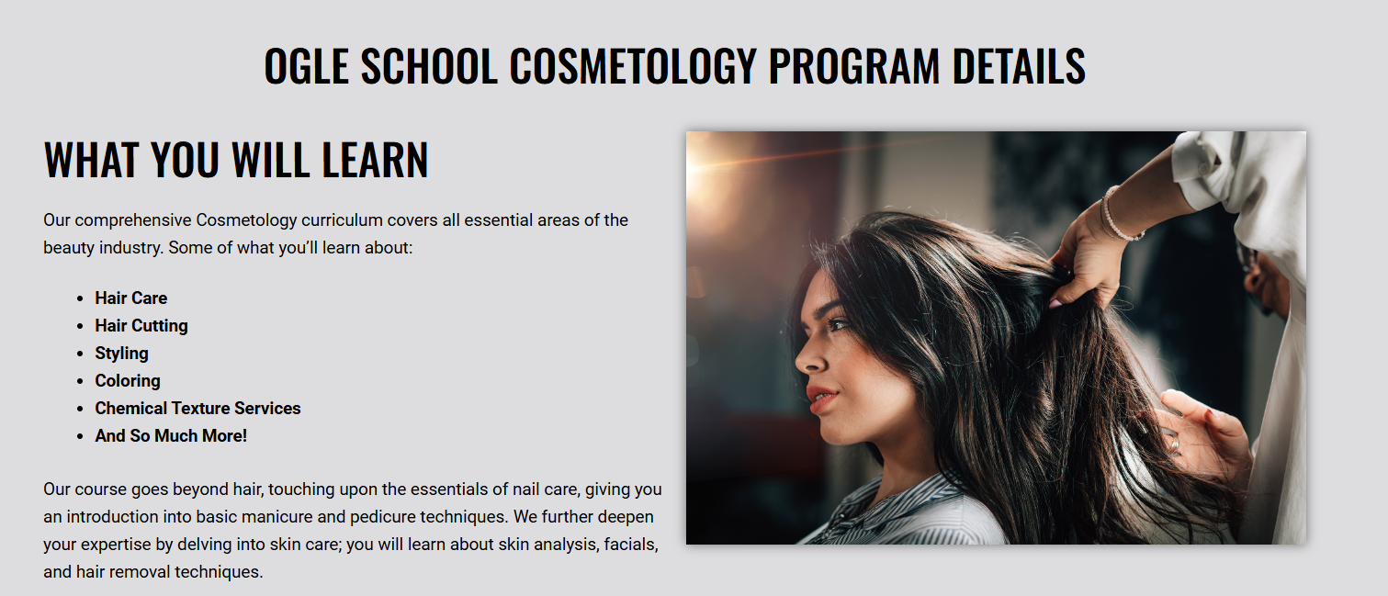

Image Academy Lash Tech Courses Details (h2)

What Students Will Learn? (h3)
Explore the incredible opportunities available in the Lash Tech industry with our professional courses. Our curriculum covers a wide range of topics, including:
- Basic Lash Application
- Advanced Techniques
- Health & Safety
- Lash Theory
- Client Assessment
- Lash Removal Techniques
- Lash Lifts & Tints
- Classic Lashes
- Volume Lashes
Don’t miss the opportunity to become the best Lash Tech you can be, and get enrolled in the Image Academy Lash Tech classes near me program at Houston today!



Kick Start Your Lash Tech Journey Today! (h2)
Start your journey of making beauty even better with Image Academy’s excellent lash Start your journey of making beauty even better with Image Academy’s excellent lash tech course. Unlock possibilities and enhance the lives of so many with every perfect set of favorite lashes. Enroll today and begin the most rewarding career as a lash tech with the best trainers of lash tech near me in Houston!
CTA: Request for Pricing
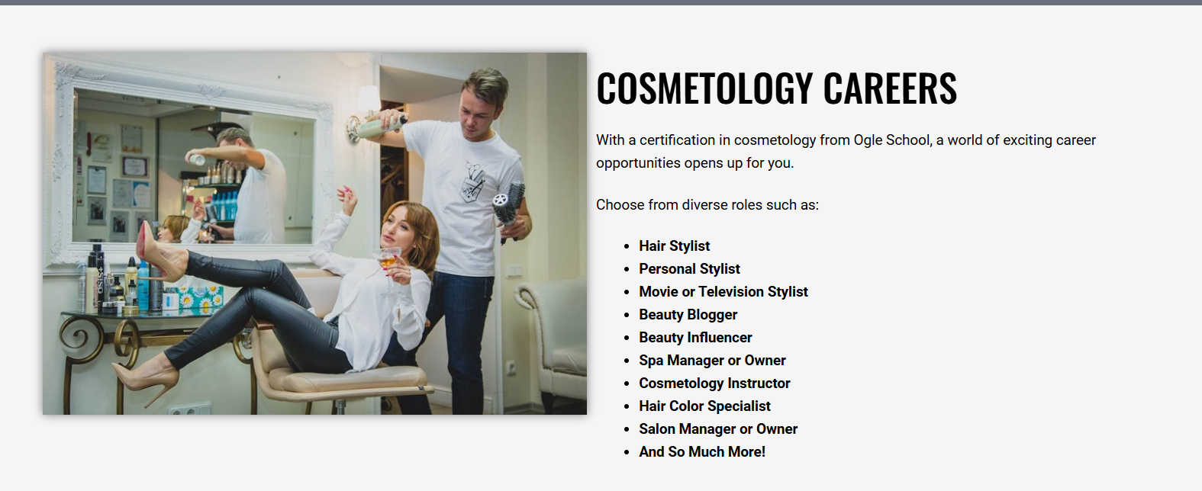

Lash Tech Careers (h2)
When you get a lash tech certification from Image Academy, a whole world of countless opportunities is offered to you.
Select from our wide range of lash tech roles, such as:
- Lash Specialist in High-End Salons
- Lash Educator or Trainer
- Lash Artist for Fashion Shows
- Eyelash Extension Product Developer
- Mobile Lash Technician
- Blogger or Influencer Specializing in Lashes
- Salon Owner or Manager
- Freelance Lash Stylist
- Lash Stylist for Movies and TV Productions
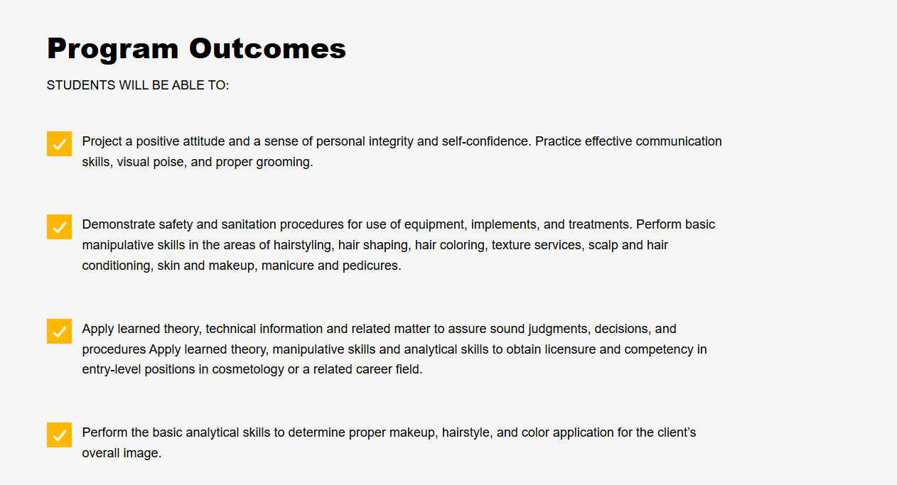

Outcomes of the Program (h2)
Students will be able to:
- After the end of the Lash Tech Program at Image Academy, the students master all important aspects of eyelash extensions such as the classic and volume eyelash extensions.
- With our all-encompassing eyelash extension course that touches on the most important aspects of eyelash extension as well as application, removal, eyelash extension aftercare, and business acumen, students will be well-equipped to thrive in the lash extension industry.
- Our highly qualified trainers give attention to individual tuition and give life models for practice to prepare the students to handle cases on their own when they are through with the course.
- We offer our graduates support and networking sessions after every one and a half years. This way, the graduates will be informed of the trends and techniques comprising the course and will continue to progress in their training upon the course’s completion.

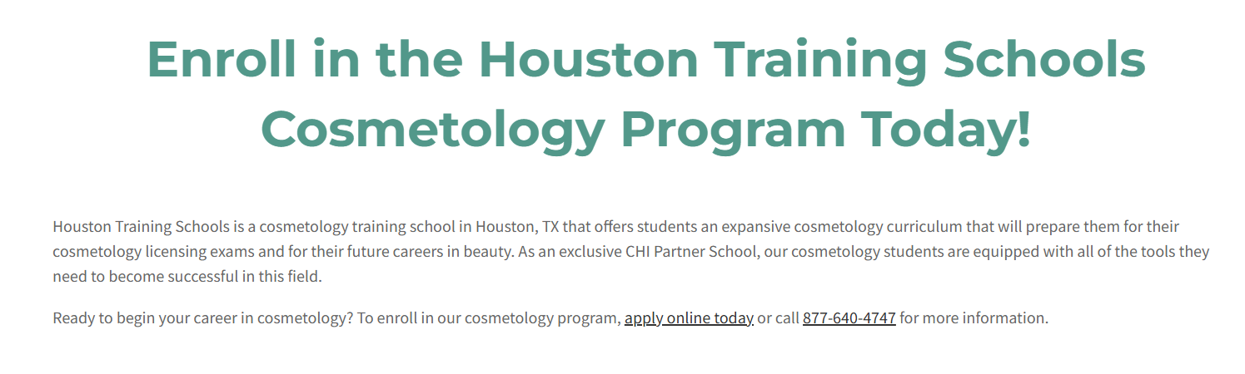

Get Enrolled in the Image Academy Lash Tech Program Today (h2)
Interested in enrolling in the best Lash Tech Program now? Embark on a successful lash extension career by enrolling at Image Academy, the best beauty academy in Houston! The lash extension Program offered at Image Academy will allow you to master the necessary knowledge and get all the required skills.

Don’t waste any time; enroll with us today and start on the path of becoming a professional lash technician. To enroll in our extension program, apply now through our website or leave a call at (281) 692-4892 for further information.
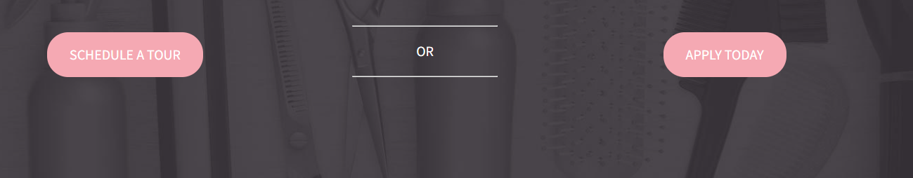

Join Us Today | Enroll Now

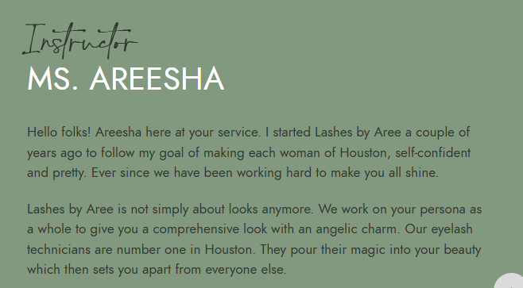

About Your Instructor (h2)
MS. Areesha (h3)

Here at Image Academy, we are honored to have Ms. Areesha at our helm to guide our students to success in Lash Tech Course Instruction. Ms. Areesha not only possesses profound theoretical knowledge but also directly prepares each client to be as comfortable and proficient as possible in performing lash extensions. Many of our lash tech course students are happy to be learners under her guidance.By embracing herself to the mission and devotedness, Ms. Areesha has become an essential figure in our mission to deliver excellent education and transform the beauty profession in Houston.

Note: Miss Areesha's picture will also be included.


Adjust this section vertically somewhere.

